Name: DEVA SANDHYA M
Registration Number: 1925260074
Course Code: CSA0701
CO-4 ASSESSMENT

1.STAR TOPOLOGY:
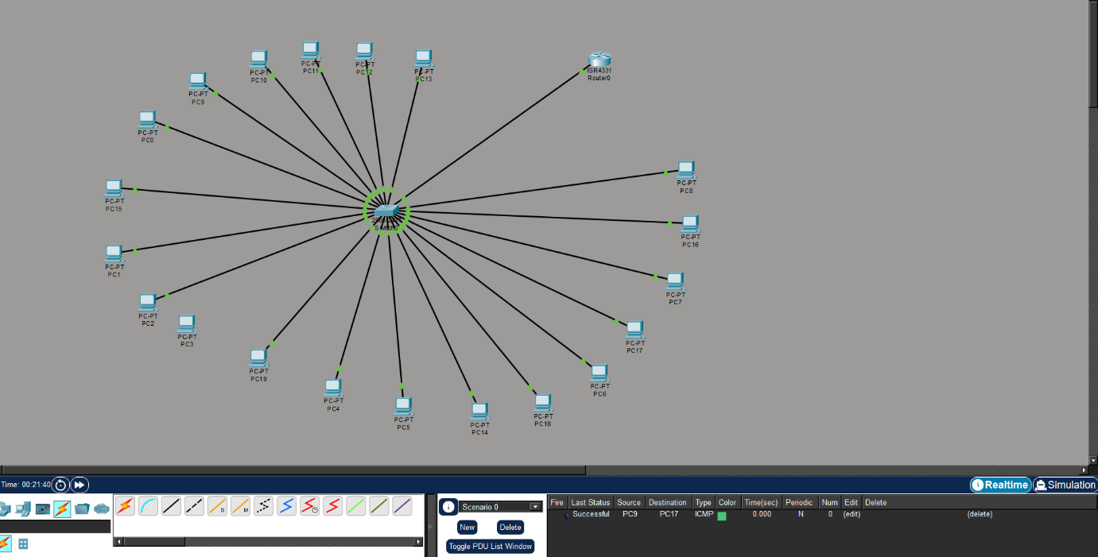

2.MESH TOPOLOGY:
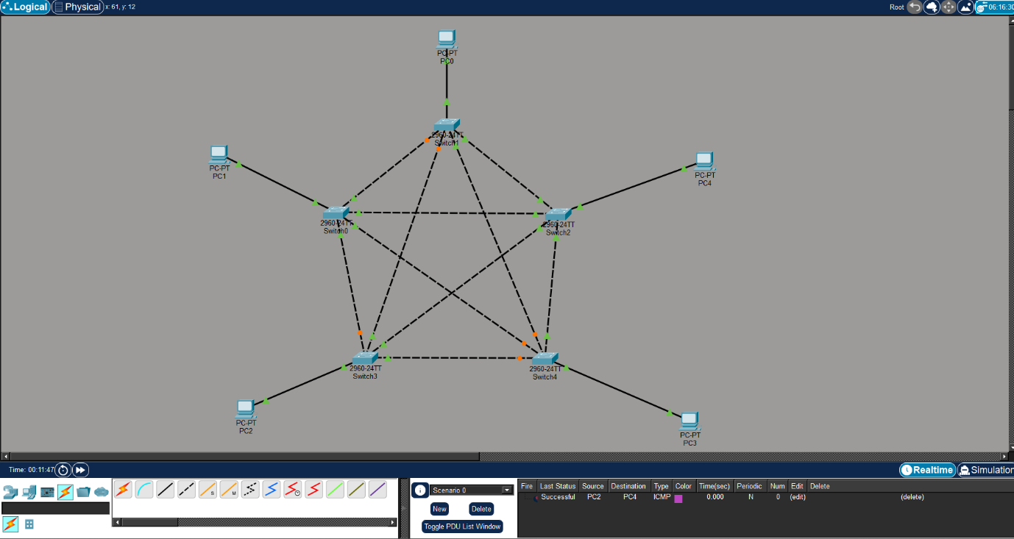

3.BUS TOPOLOGY:
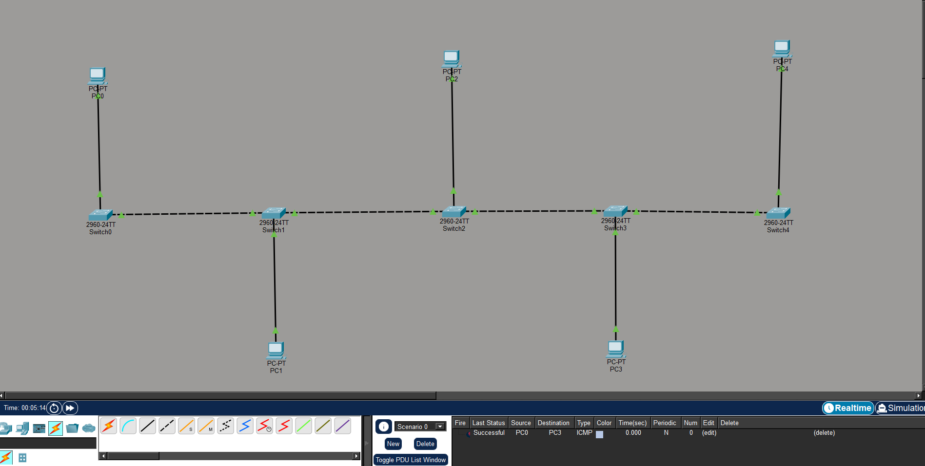

4.HYBRID TOPOLOGY:
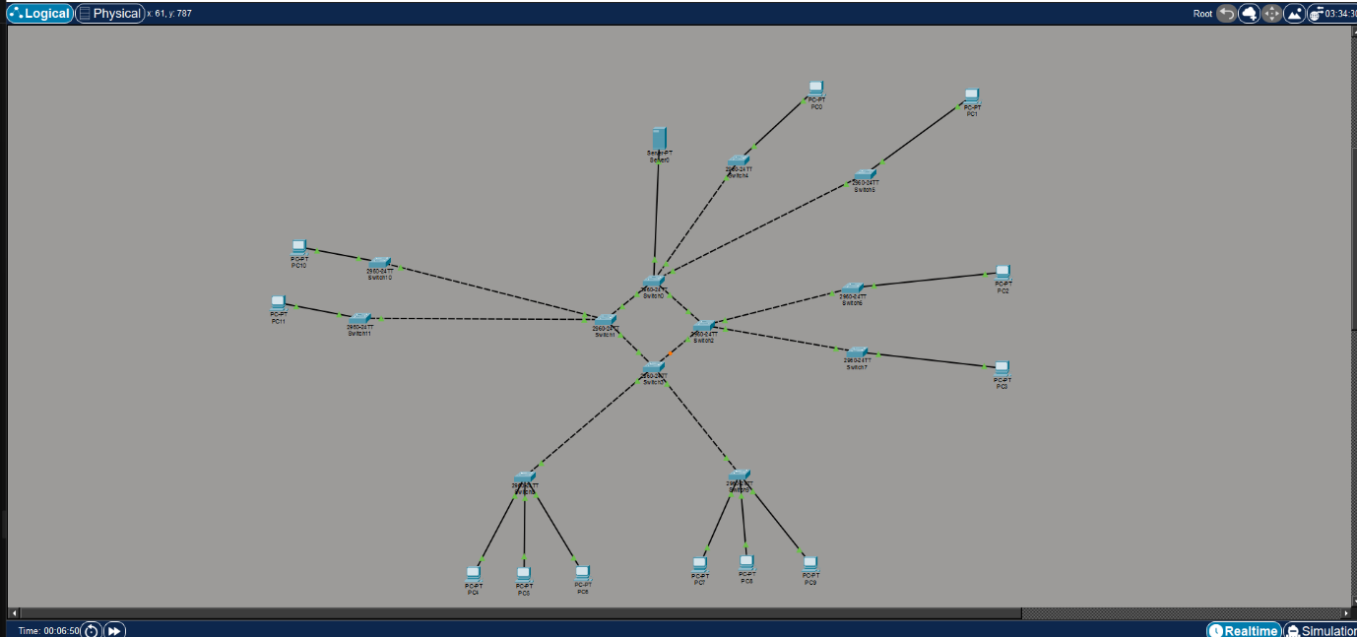

5.TREE TOPOLOGY:
